The Saint Louis University Allied Health Building is located at 3437 Caroline Street (we recommend using the Hickory East Parking Garage rather than this given address if you are using a GPS). Specific driving directions from each of the major highways to the nearest parking garage are provided below:

Directions: From Highway 70 eastbound towards the city: Take the Grand Avenue exit, make a right onto Grand, and proceed to Chouteau Avenue. At Chouteau Avenue, turn left. Proceed to South Theresa Avenue and turn right. Continue through two stop signs until the road ends at the entrance to the Hickory Parking Garages. Turn left into the Hickory East Parking Garage. See directions at the bottom of the page for where to go after you park.

Directions: From Highway 55 heading westbound (from Illinois or South St. Louis): Merge onto Highway 44 west and proceed to the Grand Boulevard exit. Make a right onto Grand and proceed to Chouteau Avenue. At Chouteau Avenue, turn right. Proceed to South Theresa Avenue and turn right. Continue through two stop signs until the road ends at the entrance to the Hickory Parking Garages. Turn left into the Hickory East Parking Garage. See directions at the bottom of the page for where to go after you park.

Directions: Highway 64/40 heading westbound from the city: Take the Grand Boulevard exit. Make a left onto Grand and proceed to proceed to Chouteau Avenue. At Chouteau Avenue, turn left. Proceed to South Theresa Avenue and turn right. Continue through two stop signs until the road ends at the entrance to the Hickory Parking Garages. Turn left into the Hickory East Parking Garage. See directions at the bottom of the page for where to go after you park.

Directions: From Highway 64/40 heading eastbound towards the city: Take the Grand Boulevard exit. Make a left onto Grand and proceed to proceed to Chouteau Avenue. At Chouteau Avenue, turn left. Proceed to South Theresa Avenue and turn right. Continue through two stop signs until the road ends at the entrance to the Hickory Parking Garages. Turn left into the Hickory East Parking Garage. See directions at the bottom of the page for where to go after you park.

Directions: From Highway 44 heading eastbound towards the city: Take the Grand Boulevard exit. Make a left onto Grand and proceed to proceed to Chouteau Avenue. At Chouteau Avenue, turn right. Proceed to South Theresa Avenue and turn right. Continue through two stop signs until the road ends at the entrance to the Hickory Parking Garages. Turn left into the Hickory East Parking Garage. See directions at the bottom of the page for where to go after you park.

Once parked, proceed to the fountains and statue just south of the garage entrances. There is a door to the Allied Health Professionals Building to enter and proceed to the atrium at the center of the first floor where the registration table will be set up.
Please see attached map.
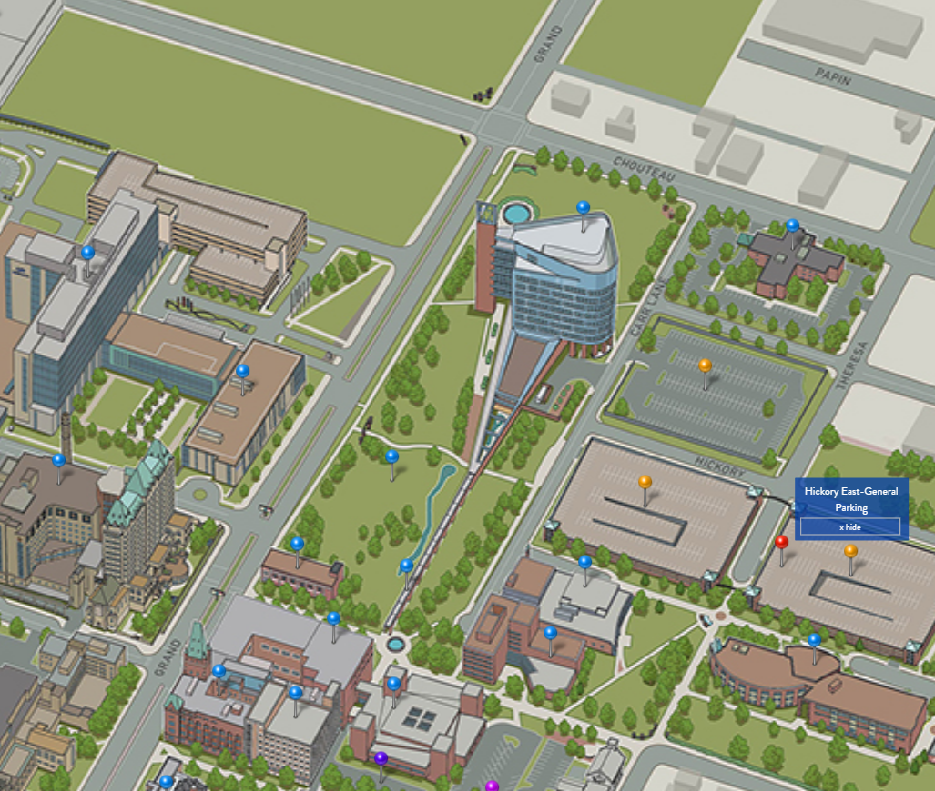
Enter building here.

We are NOT located at the hospital.
Park Here

