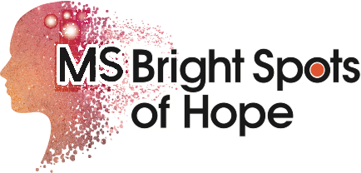

Donation to benefit MS Bright Spots of Hope

The mission of MS Bright Spots of Hope (501c3) is to educate, empower, spark creativity, and enhance wellness for the MS community and broader community through engaging programs featuring positive MS role models.

Donor name_______________________________________
Address____________________________________________
____________________________________________________
Phone______________________________________________

Please return the information to:
MS Bright Spots of Hope
12004 Jacobson Ct
Bridgeton, MO 63044

